After first view on app client pointed the following changes :

1. Herd Census acessor is not exactly like excel, the column values should be percentages to total 100%:

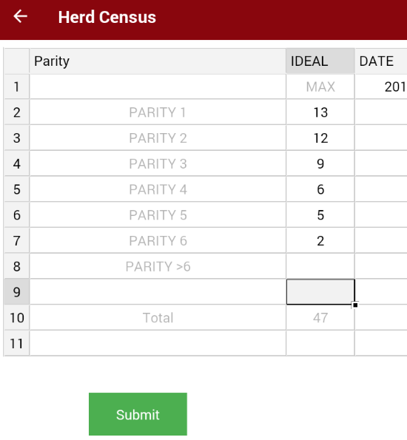

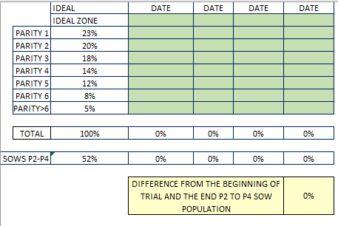

2. All the graphs should have this color reference (and we've confused the colors, number 3 is the worst, should be red, 2 orange, 1 green, 0 no evaluation), client doesn't want numbers in the graphs:

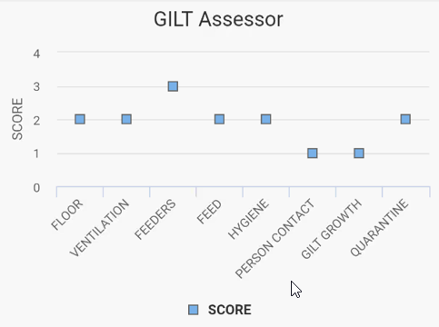

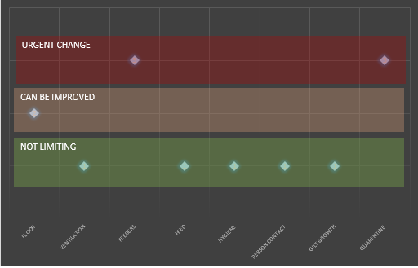

3. more GILT parameters. They want to add : Density ; Gilt Conformation and Gilt Retention

4. When seeing the graphs one can see the picture, but it would be good to see the comments as well

5. Change name of ClawCollection to Claw Evaluation

6. They want a new asessor called Notes, that is just a notes field, but will show in final PDF report.

7. Change name of Herd Census to Herd Profile

8. Change name Cull to Replacement

App:

- Change user for a simple one with no reference to names so that client can use for testing

- There is still no icon on the app

- We need to check an .ipa version as well

- On creating a new evaluation shows select farm twice : <https://is.gd/OHOnSy>

- On creating a new group shows slect group twice

- Claw collector assessor breaks the app

- Assessors we need to chose more appropriate icons

- Field Sheet and Claw Collection Sheet are just pdf for download

- If possible Claw collection sheet could have farm and date filled in, or else just put a blank PDF

- In Herd Census block would it be possible that date fields could be filled with current date when double clicked ? If it is too hard, let it go

- On asessors one needs to be able to open image on comments bigger

- In Gilt Break Even : Feed table needs to more rows (ie. feed5 and feed6); Weight and lean, column of kgs should not be editable; MARGIN/SOLD PIG

field is not editable and it's a formula; cannot fill in correctly retention rate; Sold pig table is not present

- Claw collection instead of a grid, have a table with scoring for all animals of the group : <https://is.gd/uW0C9O>

- Field sheet graph missing

- Lactation graph valuse is not correct

- Images sometimes not shows for assessor

- Insemination images fail to show in graph though they are uploaded

- Table when scroll from right to left they vibrate the sheet

- Images in graph are starting from the end instead of first image come first

- Body score end field missing from lactation assessor

- Offline login missing

- Please put validation when user enter value greater than max value allowed wherever table is applied

- At times table cell print value 0 of its own

Backoffice:

- When is it possible to move to final server

- We should be carefull using real names and emails on testing (if possible use demo names and demo emails, if needed create email in hosting for tests: <https://is.gd/kyYQKx>)

1. When user click on farm it should follow same flow of app

Farm>group>assessor n graph

With edit option

Please implemnt splash screen n login for app ,admin and register as shared earlier

1. App needs icon
2. The flow of producing the evaluations seems nice
3. We needed to edit back an evaluation in case we need to correct something
4. We needed to check photos after uploaded
5. to check the graphs, we need to be able to choose the right farm > evaluation (the date and name of person here is hard to choose the right evaluation.  I suggest a list of latest evaluations by date (more recent ones first) so that a person can choose the right group.)
6. Sometimes the tapping on items seems to take a second of delay, is this normal ?
7. There are still graphs not working
8. On the backoffice also i cannot see the evaluations, maybe is still in development
9. Is it working in offline ?

1. adding all assessor icons on the assessor menu.

2. There should only be 3 star (as all evaluations are always 1, 2 or 3)

3. Option of upload photo under comments (even if not functionable, it would be great just to have the reference at least in one assessor)

Latest changes or feedback document

<https://docs.google.com/document/d/10PGEN1aPYXTsWfKDCsUZQ6Tt1FqyLYHgzvN7nQWDmV0/edit>

Please go thru all atttachments and email feedback and feel free to connect with me for any further queries